Rambati Lumbung Pardja

222212833

3SI1/31

TEKNOLOGI PEREKAYASAAN DATA

**screenshot data CSV hasil dari tugas no 2,3,4**

**No. 2**

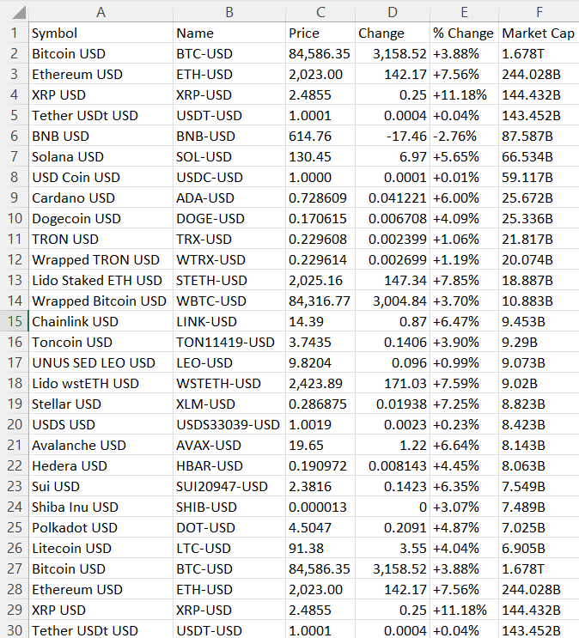

**Sumber:** [**https://finance.yahoo.com/markets/crypto/**](https://finance.yahoo.com/markets/crypto/)

**No. 3**

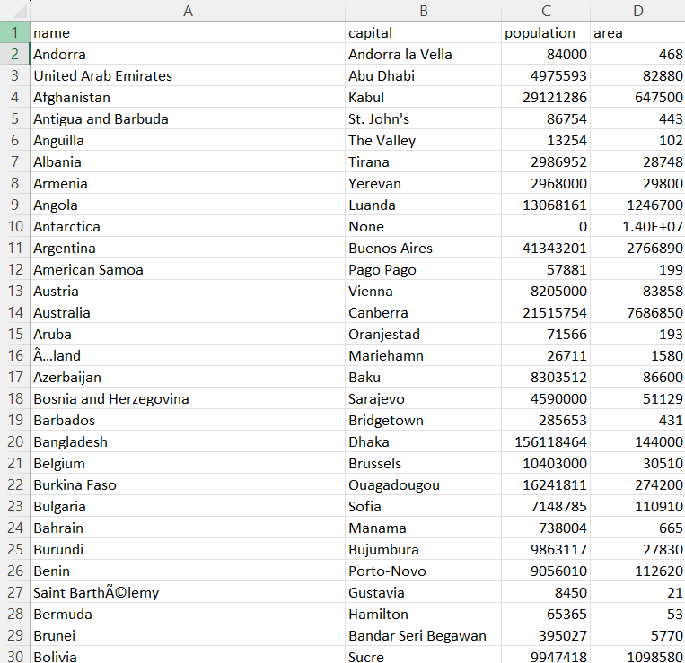

**Sumber:** [**https://www.scrapethissite.com/pages/simple/**](https://www.scrapethissite.com/pages/simple/)

**No. 4**

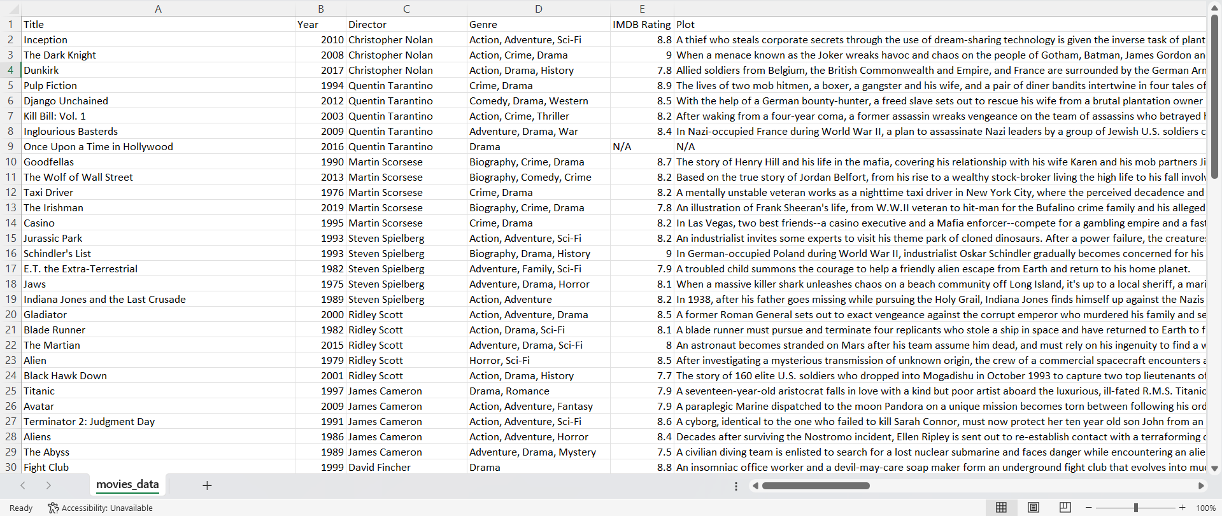

**Sumber:** [**https://www.omdbapi.com/**](https://www.omdbapi.com/)